Leadership Style
Student’s Name:

Lecturer’s Name:
Course Title:
Date:

Effective leaders have a style or a combination of several styles that usually makes them to be successful in providing guidance and inspiring their employees. Leaders who are successful in running organizations are capable of driving creativity and productivity, while at the same time improving on the bottom line of the business. At times leaders might end up being ineffective due to the leadership style that they chose to use –at times leaders might choose leadership styles which do not correlate well with the industry within which they operate in or even the type of people that they are attempting to lead. This paper is going to tackle my leadership style which is coaching.
My Leadership Principles
One of my leadership principles is that of exhibiting passion which I think is the best way to motivate my teammates. The enthusiasm for what the group is working on, the I-Core project, shows the commitment and the sense of stability and it also energizes them to keep on working hard. The project is filling a large part of my life and I believe that it is worthy sacrificing our time, resources and energy for. At times when I feel stressed or down, I recall that as a leader I do not have the luxury of allowing this to affect me as well as those whom are working under me.
The second leadership principal that I have is that of knowing myself. A leader needs to know himself or herself in such a way that he or she will use his abilities to move his team forward. An effective leader needs to have strong values which will guide his or her life. A leader also needs to be aware of the organization’s structure and his or her personal responsibilities. Also, as a leader I need to come up with ways through which I can execute the ideas that I have for my team in an effective way. A great leader needs to be able to come up with ways through which he can move his or team forwards by having effective ways of executing ideas.
The third principle of leadership that I have is that being responsible. It is important for any leader to understand that in any group that they lead that everything and everyone is their responsibility. The teammates will always look up to their leader for the final say on all the things that they do, so that there will be no room for blame. I have got to appreciate and learn to embrace this obligation, and also to take responsibility whenever I go wrong since before the teammates that I lead will always have the final say from me before embarking on anything.
I also follow the principle of being self-motivated. Teammates will always work well whenever they are motivated and thus I find it to be my responsibility to have them motivated. As a great leader, I motivate my teammates openly and without hesitation. I have always being rewarding creativity so that I can have the teammates keep on brainstorming for more ideas towards finishing our project. For the I-Core project to have real steps towards accomplishment, ideas need to remain fresh and relevant.
The last leadership principle that I follow is that of having a clear visions and goals. This means that having a clear vision for the team, where it fits into the industry and the plan that I have to make the project serve well its purpose. Thus, in this case it will be important to have goals set that are relevant to the kind of project that is at hand.
My Leadership Model in a Visual Form
Situational Leadership
In the above model of leadership, the focus is on the prevailing level of teammates –their capability and capacity to execute their assigned tasks in an effective way and to complete the tasks. In this style of leadership, the leaders typically has a much better awareness of his teammate’s capabilities. The latter perception translates that deadlines and expectations of the work process are much more realistic and the teammates better feel that their leader can relate to them. Also, situational leadership model allows team leaders to push the rest of the team members to continue working on their own skills and also start initiatives that are meant to improve their capabilities and knowledge. Thus, as a result, the group’s talent pool keeps on growing making it possible for the group to realize its ultimate goals. The group will also be assured of continued evolution that will enable it to meet its current needs and keep it abreast of the challenges that might ensue as time goes by.
Fig. 1
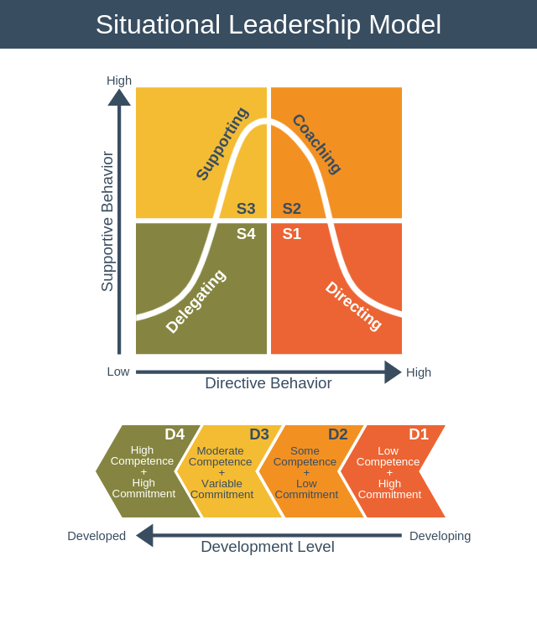
https://expertprogrammanagement.com/wp-content/uploads/2018/11/Situational-Leadership-Model.png
Ethical Perspective I Use in Making Business Decisions
Facts
Fundamental authority in business ethics generally speaking anticipates that associations should perceive express good benchmarks, which every now and again infers different things to different people. As affiliations continue to create and develop, new individuals are contracted who probably won't have undefined good models from individuals beforehand working in the association. A differentiation in ethics much of the time changes how individuals approach the essential authority process. Associations much of the time use the affiliation's mission statement to manufacture a framework for helping individuals choose moral business decisions.
The two Principles that I Want to Continue Working on
Two of the principles that I want to continue working on is that of knowing myself and that of being self-motivated. I expect to receive critics on the principle of knowing myself because I cannot be perfect in all areas, thus I need to know the areas where I will be required to improve. Also, at times I might motivate some of my group members openly without hesitation and then the rest of the group members ends up criticizing my actions although they were in order with some of the things that might have taken place in the group.
Steps to Improve in Each of these Areas
For the case of improving on knowing myself, I will be honest with myself so that I can know the areas where I need to improve and the ones that I am perfect on. Through the latter, I will be able to improve on skills that are not well-developed and to continue trying hard to improve on such areas. I will keep on asking myself thoughtful questions so that I can be able to pin point the areas that I need to work on.
On the other hand, with regard to improving on motivation of the workers I will have in place ways that will foster collaboration within the team. I will also offer the teammates opportunities for self-development so that they can improve on areas that they might be having some weaknesses.
Bibliography
EMMANUEL, DR L R. 2019. LEADERSHIP PRINCIPLES FOR SUCCESS. [S.l.]: XULON PRESS.
Fellowship of Christian Athletes. 2011. The greatest leader ever: essential leadership principles. Ventura, Calif: Regal.
Fernando, A. C. 2010. Business ethics and corporate governance. Delhi: Dorling Kindersley (India), licensees of Pearson Education in South Asia.
Iqbal, Talha. 2011. The impact of leadership styles on organizational effectiveness: Analytical study of selected organizations in IT sector in Karachi. Munich: Grin Verlag
Rajbhandari, Mani Man Singh. 2015. Critical Perspective on Situational Leadership Theory. Leadership Readiness for Flexibility and Mobility. The 4th Dimensions on Situational Leadership Styles in Educational Settings.

Iqbal, Talha. 2011. The impact of leadership styles on organizational effectiveness: Analytical study of selected organizations in IT sector in Karachi. Munich: Grin Verlag
Fellowship of Christian Athletes. 2011. The greatest leader ever: essential leadership principles. Ventura, Calif: Regal.
EMMANUEL, DR L R. 2019. LEADERSHIP PRINCIPLES FOR SUCCESS. [S.l.]: XULON PRESS.
Rajbhandari, Mani Man Singh. 2015. Critical Perspective on Situational Leadership Theory. Leadership Readiness for Flexibility and Mobility. The 4th Dimensions on Situational Leadership Styles in Educational Settings.
Fernando, A. C. 2010. Business ethics and corporate governance. Delhi: Dorling Kindersley (India), licensees of Pearson Education in South Asia.

